Online Blood Bank System
Technical Design Document


 | Prepared By / Last Updated By | Reviewed by | Approved By
Name | Pentakota Naveen Kumar | Rajat Bishnoi | Ashu Jauhari
Role | Team Member | Team Member | Scrum Master
Signature | Pentakota Naveen Kumar | Rajat Bishnoi | Ashu Jauhari
Date | 21/12/2019 | 21/12/2019 | 23/12/2019

Table of Contents
1.0 Introduction 3
1.1 Purpose & Scope of the document 3
1.2 System Design 3
1.3 Use case ‘User Registration’ 4
1.3.1 Use case attributes 4
1.3.2 Business Rules 5
1.3.3 UI Requirements 5
1.3.4 UI Field Validations 6
1.4 Use case ‘User Credential Authentication’ 6
1.4.1 Use case attributes 6
1.4.2 Business Rules 7
1.4.3 UI Requirements 7
1.5 Use case ‘Blood Availability’ 8
1.5.1 Use case attributes 8
1.5.2 Business Rules 9
1.5.3 UI Requirements 9
1.5.4 UI Field Validations 11
1.6 Use case ‘Blood Requirement Posting’ 11
1.6.1 Use case attributes 11
1.6.2 Business Rules 12
1.6.3 UI Requirements 12
1.6.4 UI Field Validations 13
1.7 Use case ‘Blood Donation’ 14
1.7.1 Use case attributes 14
1.7.2 Business Rules 14
1.7.3 UI Requirements 15
1.7.4 UI Field Validations 16
1.8 Use case ‘Experience Sharing’ 17
1.8.1 Use case attributes 17
1.8.2 Business Rules 17
1.8.3 UI Requirements 18
1.8.4 UI Field Validations 18
1.9 FAQs 18
1.9.1 Use Case attributes 18
1.9.2 Business Rules 19
1.9.3 UI Requirements 20
2.0 Database Design 21
2.1 Tables Structure 21
3.0 Appendices 25
3.1 Glossary 25
4.0 Terms & Conditions 25
5.0 Change Log 26

Introduction

Purpose & Scope of the document
The purpose of this Use case document is to systematically capture requirements for the project and the system to be developed in terms of use cases. Functional use cases are captured in this document. It also serves as the input for the project scoping.

The scope of this document is limited to addressing the use cases from a user, quality, and non-functional perspective.

System Design
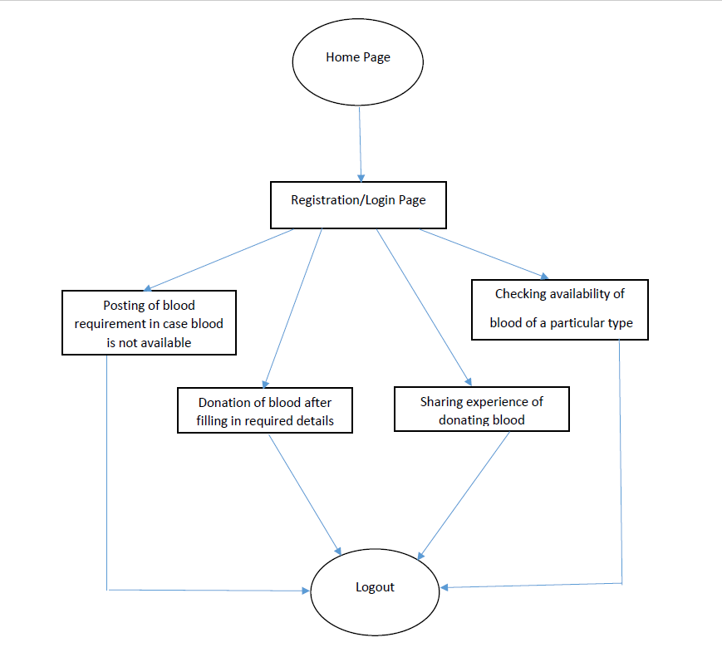

Use case ‘User Registration’

Use case attributes
Use Case Description:

This use case deals with the capture of user details. The ‘user’ here shall be the operator of the system and will be keying in the user details.

Scope:

- User registration

Actors:

- User – the operator

Trigger:

Click ‘Sign Up’ button in the ‘User Registration’ page

Pre-Condition:

User being able to access the homepage & get redirected to the ‘User Registration’ page upon click of ‘Register’ link.

Post Condition:

User is in the registration page & submit details

Flow of Events:

User at homepage → Click ‘Register’ link → User is in the registration page → User details are submitted and added onto the database

Primary Scenario:
A new user – is able to click ‘Register’ link and able to provide his details and get registered in the system.

Business Rules
Business rules should be defined using the following attributes: -

- When the user clicks on the register link, it should re-direct to registration form.
    - User needs to fill some of the basic attributes/fields as mentioned below in requirement: username ,First Name, Last Name, Age, Gender, Contact Number, E-Mail, Password, Weight, State, Area, Pin code, Blood Group;
- Clicking ‘Sign Up’ should validate the datatype constraints for each field
- Post-successful field level validation, save the information in the database
- Upon saving the information in the database, display the message ‘You have successfully registered’.

UI Requirements
Here is a prototype on how the homepage should look like.

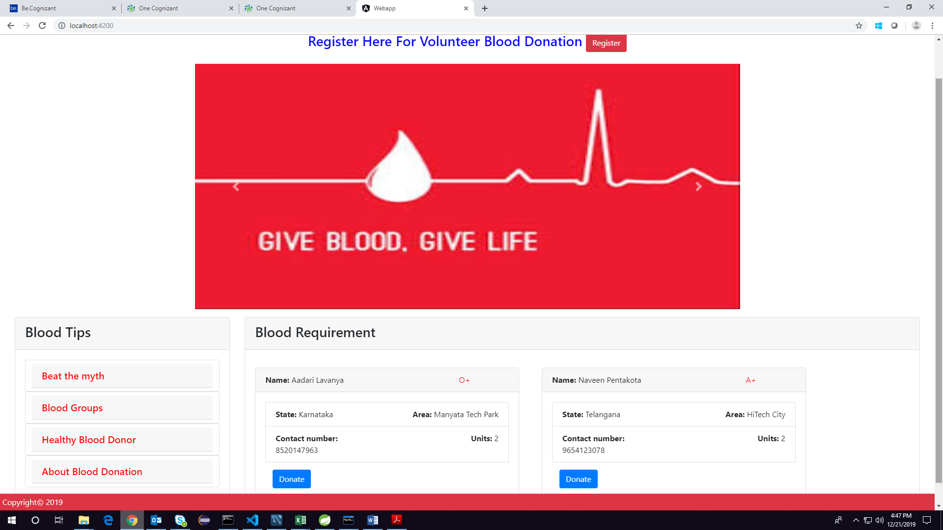

Here is a prototype on how the ‘User Registration’ page should look like.

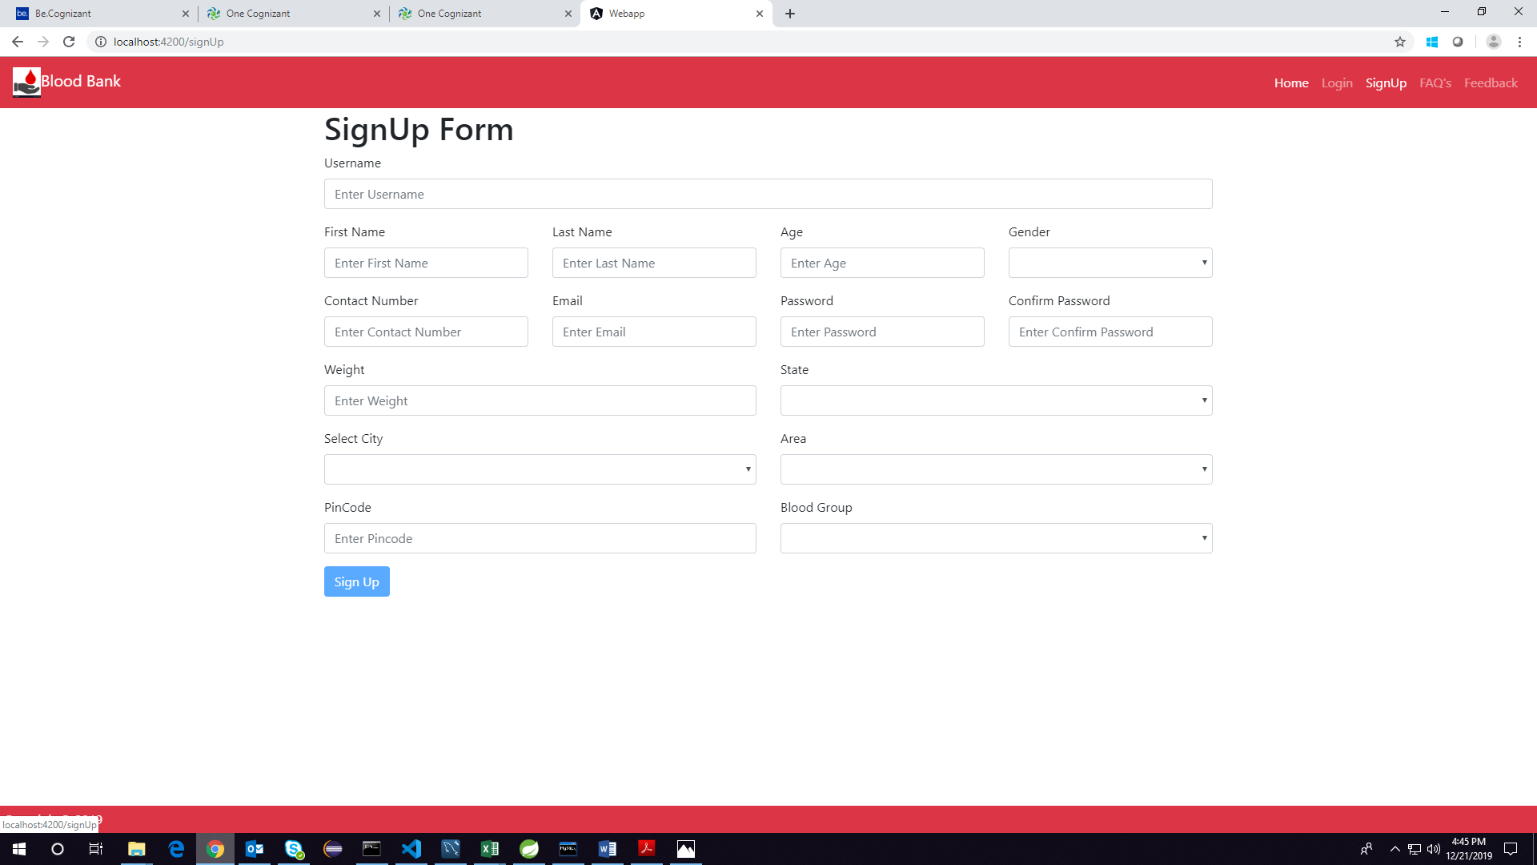

UI Field Validations
Please refer to the below requirements for field level validations:

- All fields are mandatory.
Password should have minimum 3 chars and max 15 chars, space & can contain special characters (ex !,@,#,%,*,& etc.)
- The Email ID format must be checked.
- Phone Number must be of 10 digits length
- Age should be between 16 and 65.
- First Name, Last Name, State, Area should contain only alphabets.
- Pin code should be of 6 digits and contain only numbers.
- Weight field should contain only numerical digit.

Use case ‘User Credential Authentication’

Use case attributes
Use Case Description:

This use case deals with the authentication of the user credentials. The ‘user’ here shall be the operator of the system and will be keying in the user information into the system.

Scope:
- User credentials authentication
Actors:
User – the operator

Trigger:

Click ‘Login’ link, after keying in ‘Username’ & ‘Password’ field.

Pre-Condition:

User being able to access the homepage

Post Condition:

User is in the Blood Bank Home Page.

Flow of Events:

User at homepage → Key in ‘Username’ & ‘Password’ field → User credentials are validated → Blood Bank Home page is displayed

Primary Scenario:
A registered user – is able click ‘Login’ link, after keying in ‘Username’ & ‘Password’ field and get his credentials authenticated with the existing database entry.

Alternative Scenario:
A registered user – is able click ‘Login’ link, after keying in ‘Username’ & ‘Password’ field and unable to get his credentials authenticated. The user is presented with relevant error messages: Invalid username or password.

Business Rules
Business rules should be defined using the following attributes:-

- A registered user – is able click ‘Login’ link, after keying in ‘Username’’ & ‘Password’ field and get his credentials authenticated with the existing database entry.

UI Requirements
Here is a prototype on how the Blood Bank Login should look like.

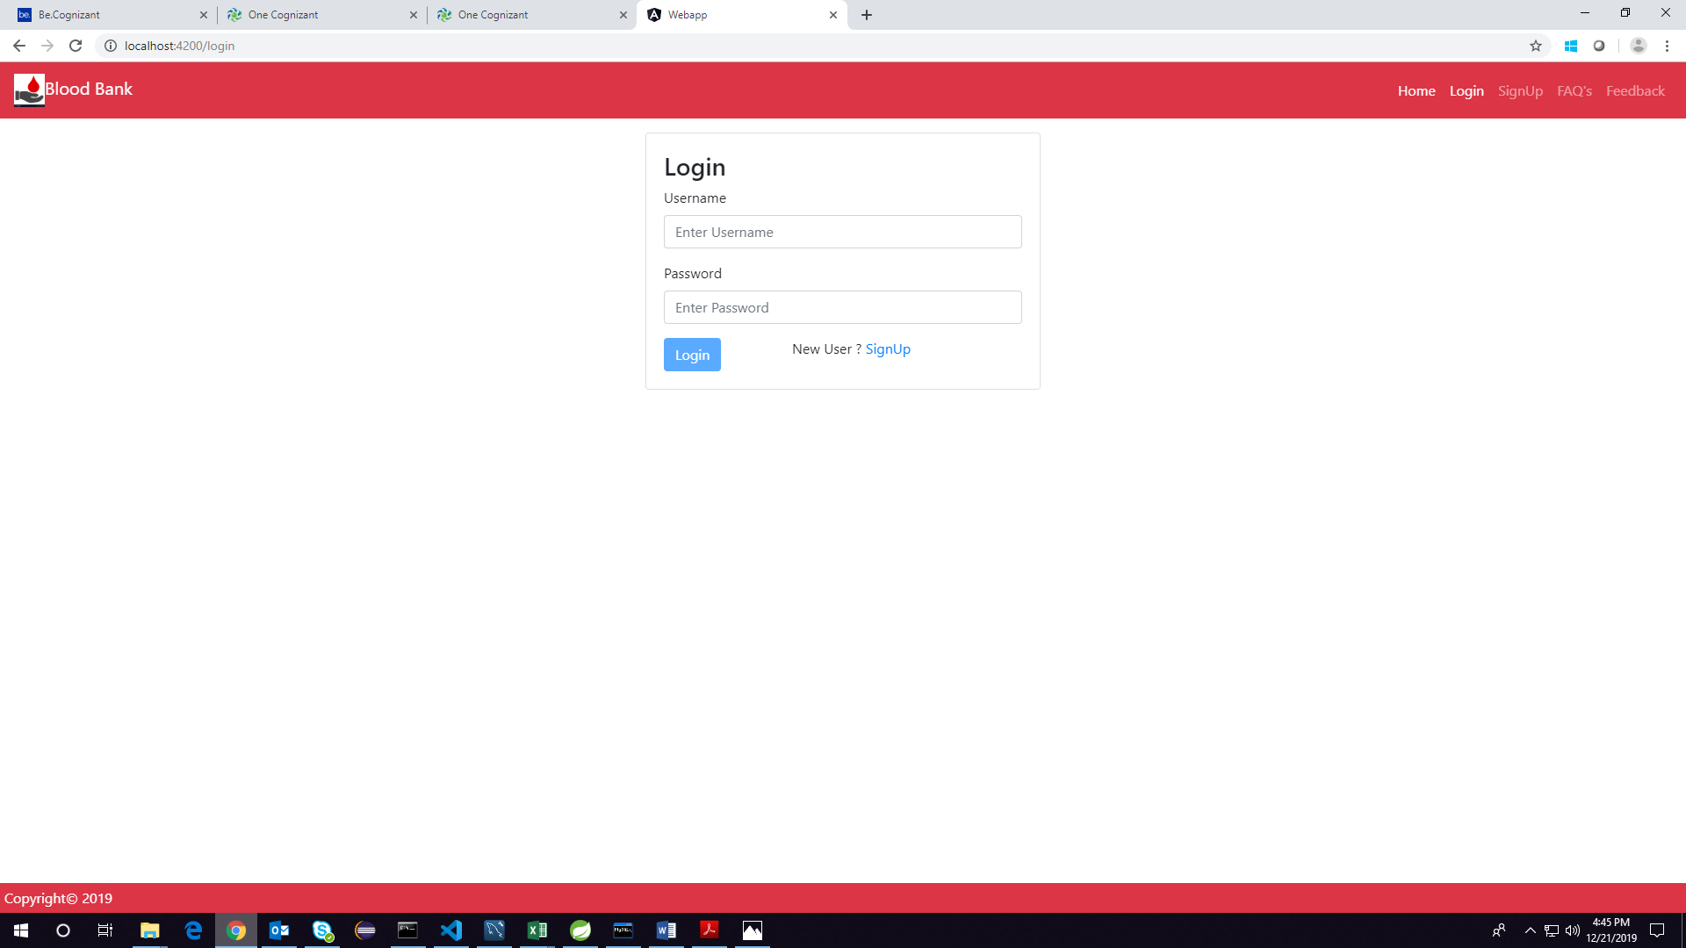

Use case ‘Blood Availability’

Use case attributes
Use Case Description:

This use case deals with the ability of the system to check for availability of particular blood type. The ‘user’ here shall be the operator of the system and will be keying in the blood availability form details.

Scope:

- Blood Availability

Actors:

- User – the operator

Trigger:

Click ‘Search’ button in the ‘Blood Availability form’ page to check for availability of blood.

Pre-Condition:

User being able to access the homepage & get redirected to the ‘Blood Availability Form’ page upon click of ‘Search Donors’ button.

Post Condition:

User is in the ‘Blood Availability Form’ page & submit details

Flow of Events:

User at homepage → Click ‘Search Donors’ button → User is in the ‘Blood Availability Form’→ Blood details are submitted and validated from the database.

Primary Scenario:
A new user – is able to click ‘Search’ button and able to provide his blood details and search for blood availability.

Business Rules

Business rules should be defined using the following attributes: -

- When the user clicks on the ‘Search Donors’ button, it should re-direct to the blood availability form.
    - User needs to fill some of the basic attributes/fields as mentioned below in requirement: State, City, Area, Blood Group;
- Clicking ‘Search’ should validate the datatype constraints for each field
- Post-successful field level validation, validate the information from the database
- Upon validating the information from the database, display the message either the results of the search or ‘Option to post Blood Requirement’.

UI Requirements
Here is a prototype on how the ‘Blood Availability form’ page should look like.

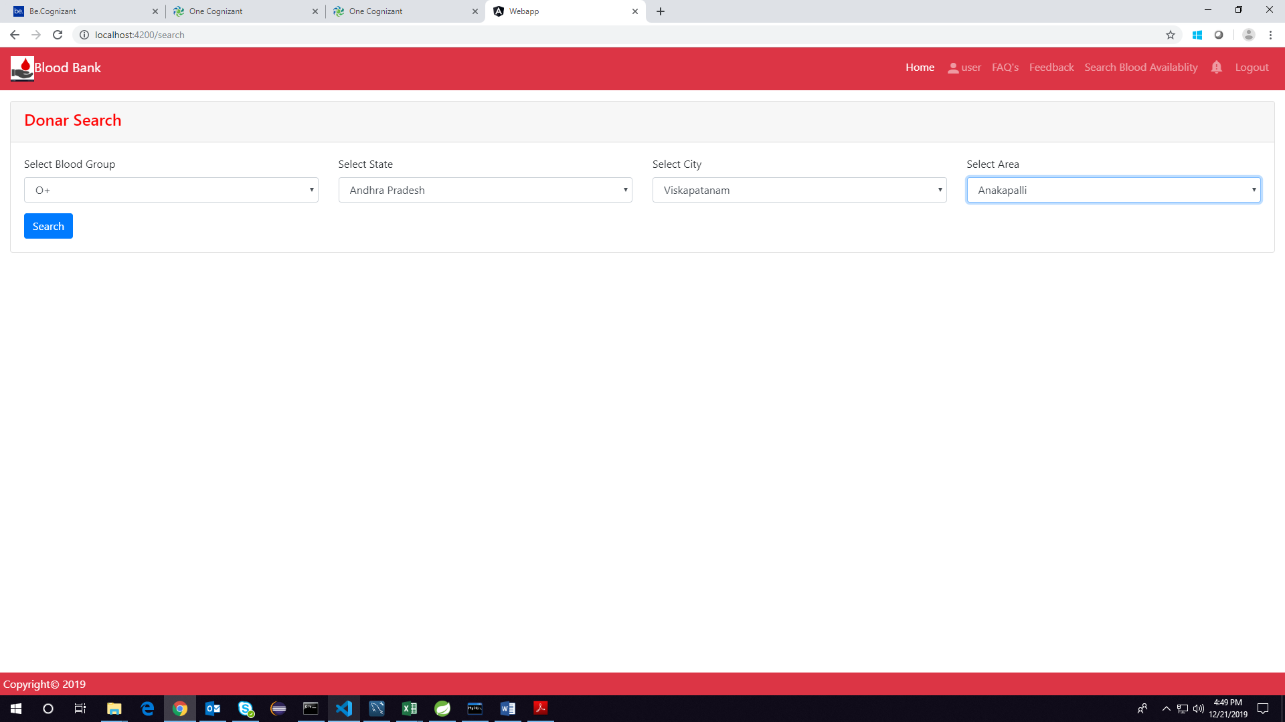

UI Field Validations
Please refer to the below requirements for field level validations:

- All fields are mandatory.
- Phone Number must be of 10 digits’ length
- State, Area should contain only alphabets.

Use case ‘Blood Requirement Posting’

Use case attributes
Use Case Description:

This use case deals with the ability of the system to post blood requirement in homepage. The ‘user’ here shall be the operator of the system and will be keying in the blood requirement details.

Scope:

- Blood Requirement Posting

Actors:

- User – the operator

Trigger:

Click ‘Search’ button in the ‘Blood Requirements Form’ page

Pre-Condition:

User being able to access the homepage. User being able to reach ‘Blood Requirement posting form’ page upon clicking ‘Search’ in Blood Availability Results page when ‘No Results Found’.

Post Condition:

User is in the Blood Requirements Form page & submit details

Flow of Events:

User at Blood Availability Results page → Click ‘Post’ button → User is in the Blood Requirements Form page →Blood Requirement details are submitted and added onto the database -> User redirected to homepage.

Primary Scenario:
A user – is able to click ‘Post’ button and able to provide Blood Requirement details and post requirements in the homepage.

Business Rules

Business rules should be defined using the following attributes: -

- When the user clicks on the ‘Search’ button, it should re-direct to the Blood Requirements form.
    - User needs to fill some of the basic attributes/fields as mentioned below in requirement: State, City, Area, Blood Group;
- Clicking ‘Post’ should validate the datatype constraints for each field
- Post-successful field level validation, save the information in the database and display the posting in the homepage.
- Upon saving the information in the database, display the message ‘Blood Requirement successfully posted’.

UI Requirements
Here is a prototype on to reach Requirement posting form by clicking on ‘Yes’ button

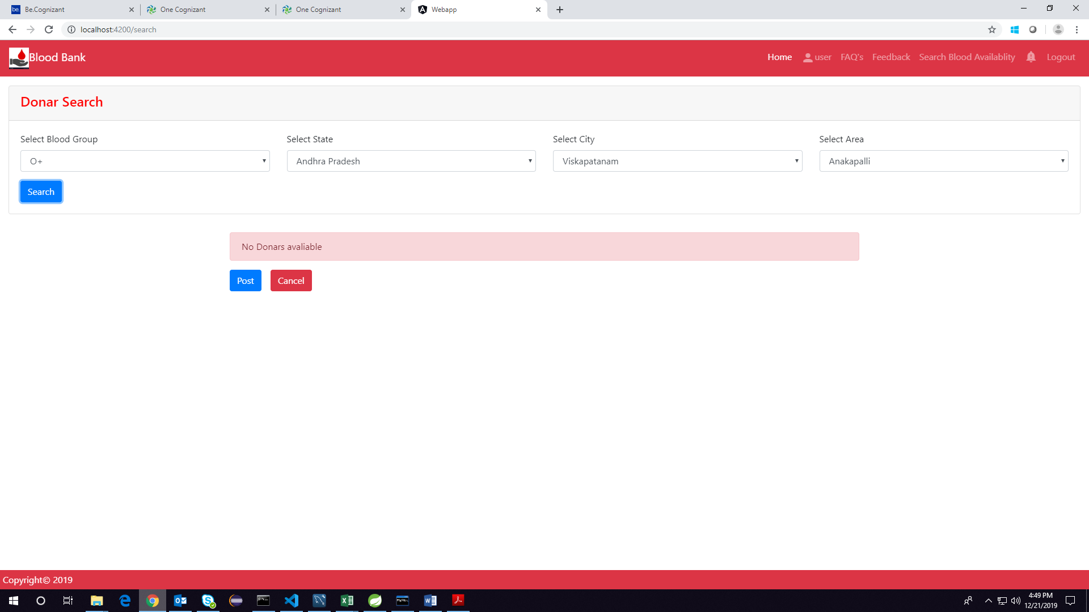

Here is a prototype on how the ‘Requirement Posting Form’ page should look like.

UI Field Validations
Please refer to the below requirements for field level validations:

- All fields are mandatory.
- State, City,Area should contain only alphabets.

Use case ‘Blood Donation’

Use case attributes
Use Case Description:

This use case deals with the ability of the system to provide information about blood donation and book a slot for donating blood. The ‘user’ here shall be the operator of the system and will be keying in the blood donation details.

Scope:

- Blood Donation
Actors:

- User – the operator
Trigger:

Click ‘Donate’ button in the ‘Blood Donation Form’ page.

Pre-Condition:

User being able to access the homepage. User being able to reach ‘Blood Donation form’ page upon clicking ‘Donate’ button in the homepage.

Post Condition:

User is in the Blood Donation Form page & submit details and reach Slot booking form page and book slot.

Flow of Events:

User at homepage → Click ‘Donate’ button → User is in the Blood Donation Form page →Blood Donation details are submitted and added onto the database -> User redirected Slot booking form page-> Slot details are submitted-> Slot details are added to database-> user redirected to homepage.

Primary Scenario:
A user – is able to click ‘Donate’ button and able to provide Blood Donation details page and save the details in database and redirect to slot booking page and save the slot booking details in the database.

Business Rules
Business rules should be defined using the following attributes: -

- When the user clicks on the ‘Donate’ button, it should re-direct to the Blood Donation form.
    - User needs to fill some of the basic attributes/fields as mentioned below in requirement: State, City, Area, Blood Group;
- Clicking ‘Book’ should validate the datatype constraints for each field
- Post-successful field level validation, save the information in the database and redirect to slot booking page
- User needs to fill some basic details like Hospital name, date, time.
- Clicking ‘Book’ should validate the datatype constraints for each field
- Post-successful field level validation, save the information in the database and redirect to homepage.

UI Requirements

Here is a prototype on how the ‘Blood Donation Form page should look like.

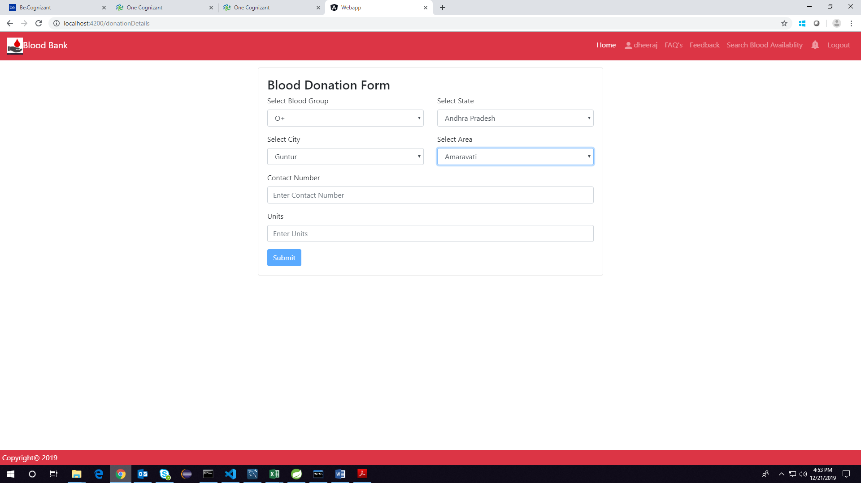

Here is a prototype on how the ‘Slot Booking Form page should look like-

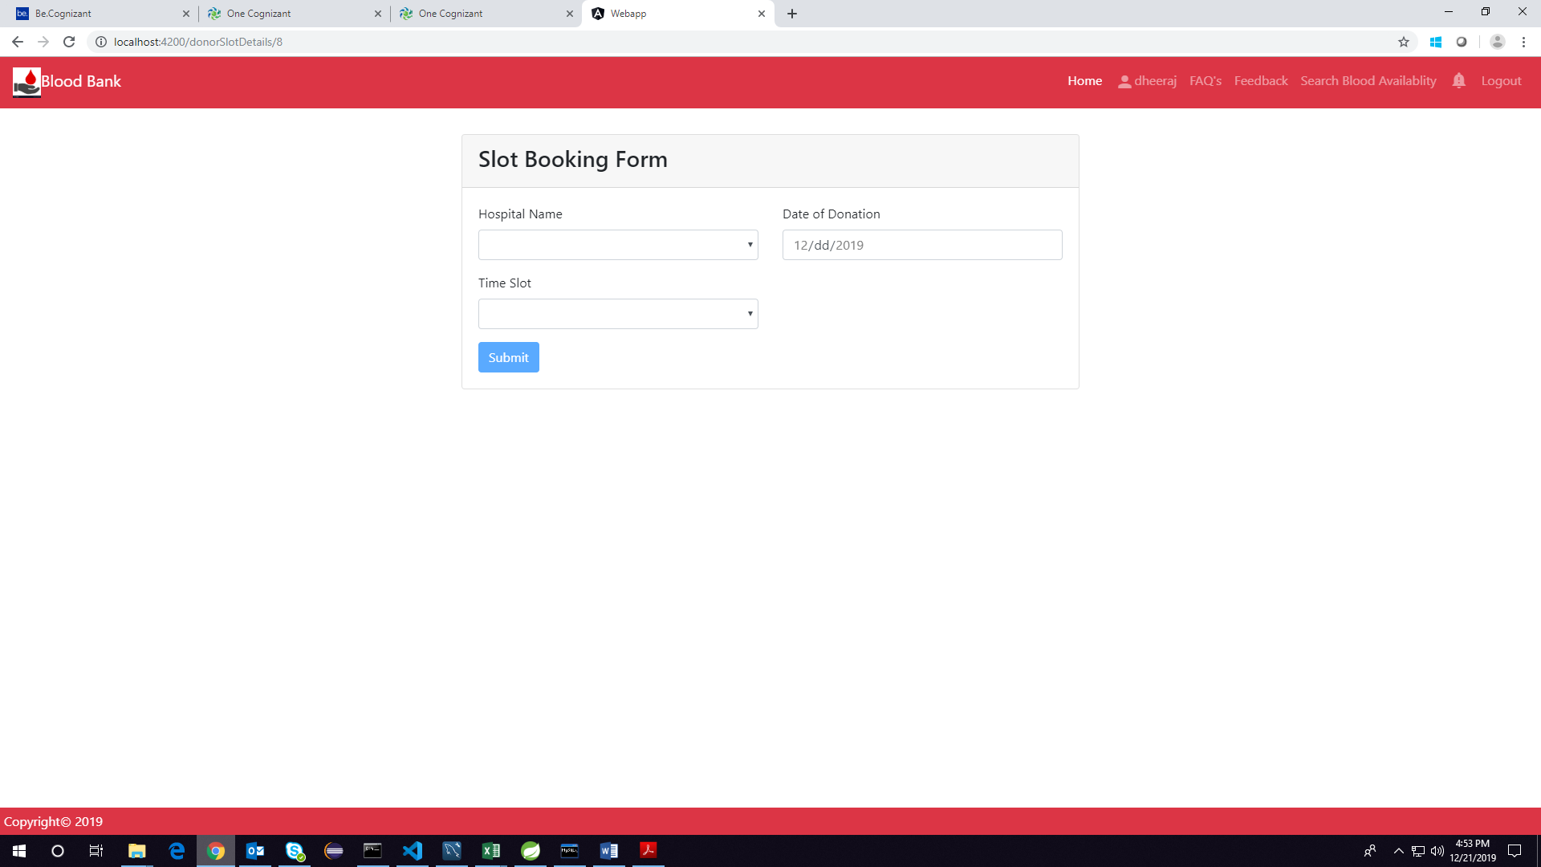

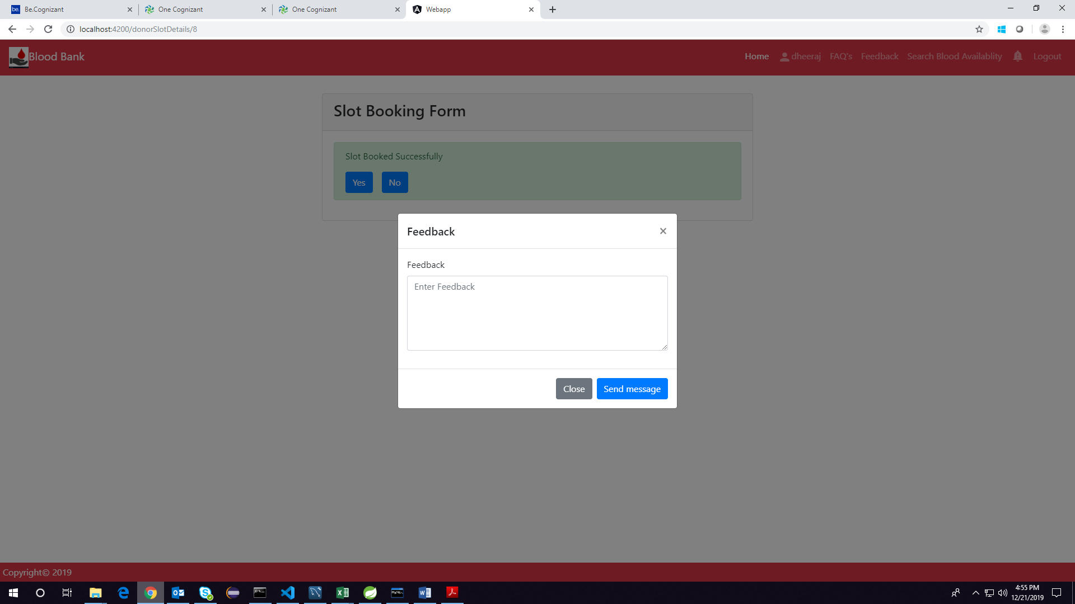

UI Field Validations
Please refer to the below requirements for field level validations:

Blood Donation Form:
- All fields are mandatory.
- State, City, Area should contain only alphabets.

Slot Booking Form:
- All fields are mandatory.
- Hospital should contain only alphabets.

Use case ‘Experience Sharing’

Use case attributes
Use Case Description:

This use case deals with the ability of the system to capture the feedback of blood donor and display in the homepage. The ‘user’ here shall be the operator of the system and will be keying in the user feedback.

Scope:

- Experience Sharing

Actors:

- User – the operator

Trigger:

Click ‘Submit’ button in the ‘User feedback form’ page

Pre-Condition:

User being able to access the homepage & get redirected to the ‘Feedback form’ page upon click of ‘Feedback’ link in navigation pane.

Post Condition:

User is in the Feedback form page & submit details.

Flow of Events:

User at homepage → Click ‘Feedback’ link in navigation pane → User is in the Feedback form page → Feedback details submitted and added onto the database.-> User redirected to homepage

Primary Scenario:
A new user – is able to click ‘feedback’ link in navigation pane and able to provide feedback details and save the details in the database.

Business Rules
Business rules should be defined using the following attributes: -

- When the user clicks on the ‘Feedback’ link, it should re-direct to Feedback form.
    - User needs to fill some of the basic attributes/fields as mentioned below in requirement: Hospital name, Area, Feedback.
- Clicking ‘Submit’ should validate the datatype constraints for each field
- Post-successful field level validation, save the information in the database.
- Upon saving the information in the database, redirect User to homepage.

UI Requirements

Here is a prototype on how the ‘feedback Form’ page should look like.

UI Field Validations
Please refer to the below requirements for field level validations:

- All fields are mandatory.
- Hospital Name, City should contain only alphabets.

FAQs

Use Case attributes
Use Case Description:

This use case deals with the ability of the system to capture the FAQs of blood donor and display in the homepage. The ‘user’ here shall be the operator of the system and will be keying in the FAQs and admin can respond to the query and user will receive notification.

Scope:
- Frequently Asked Questions

Actors:
- User, Admin – the operator

Trigger:
Click ‘FAQs’ link in the header

Pre-Condition:

User being able to access the homepage & get redirected to the ‘FAQs’ page upon click of ‘FAQs’ link in navigation pane.

Post Condition:

User is in the FAQs form page where he can see and post questions if not there already.

Flow of Events:

User at homepage → Click ‘FAQs’ link in navigation pane → User is in the FAQs form page → FAQs question is submitted and added onto the database

Primary Scenario:
A new user – is able to click ‘FAQs’ link in navigation pane and able to view previous FAQs and post his/her own FAQ and save the details in the database.

Business Rules
Business rules should be defined using the following attributes: -

- When the user clicks on the ‘FAQs’ link, it should re-direct to FAQs page.
    - User can read the FAQS answered by admin and can ask his/her own question.
- If user wants to ask his/her own question he/she can ask it in the form provided at the end of the page.
- Post-successful field level validation, on clicking ‘Ask’, save the information in the database.
- Upon saving the information in the database, it is sent to admin so that admin can answer the query.

UI Requirements
Here is a prototype on Clicking FAQs link in homepage-
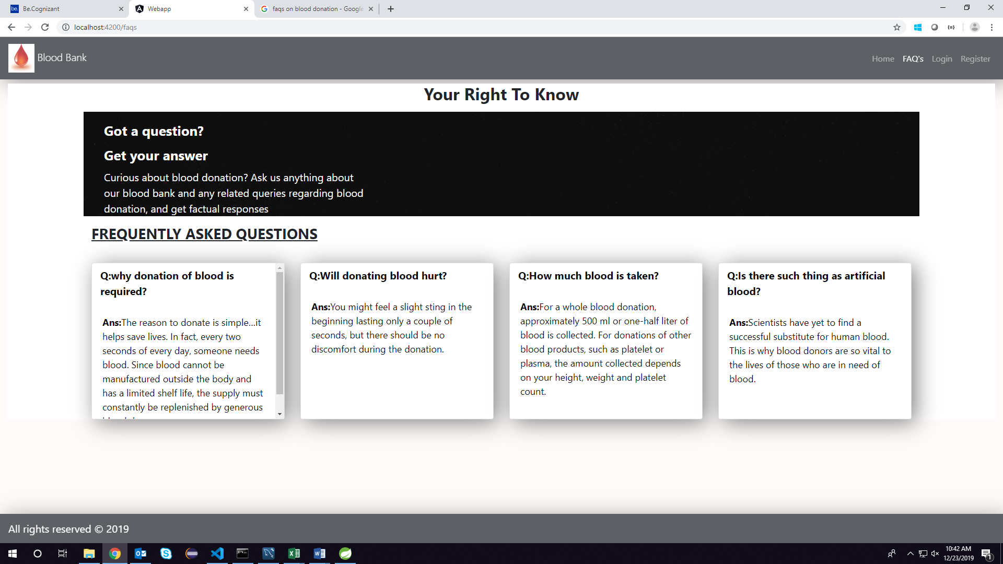
Here is a prototype of User Faq page-

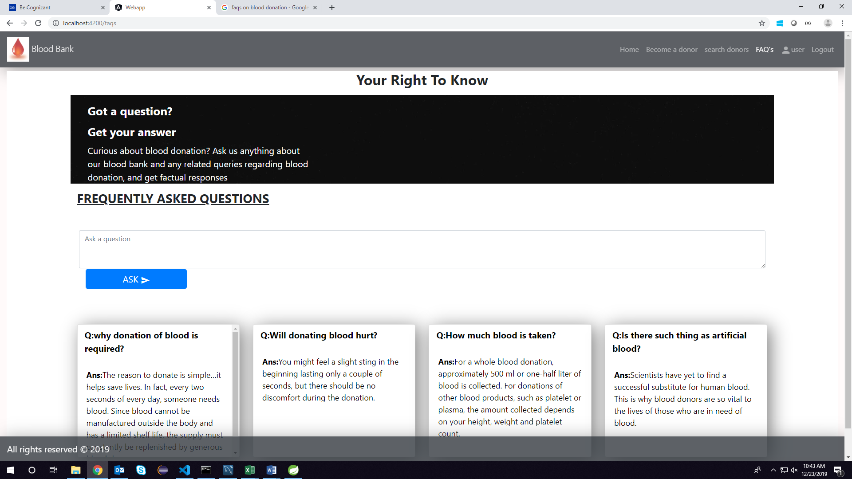

Here is the prototype of Admin Faq page

Database Design

Tables Structure
User Details Table:
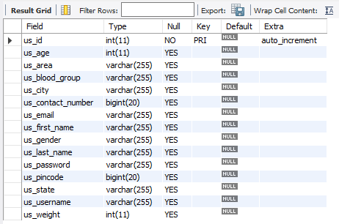
Role Table
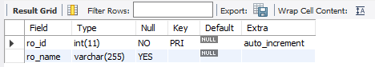
UserRole Table
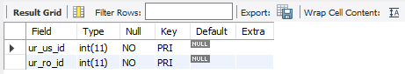

Blood group table
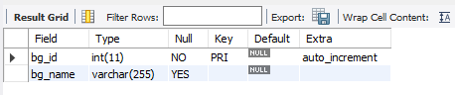
State table
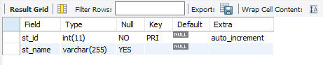
City table
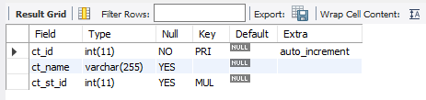
Area table
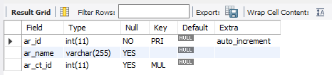
Hospital table
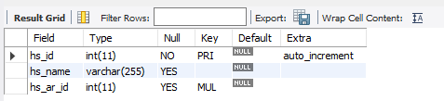

Request blood table
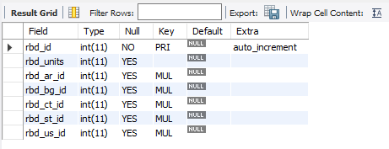
Donation details service
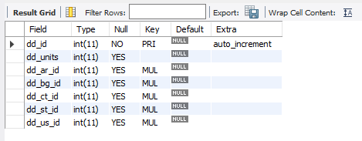
Donor willing slot booking table
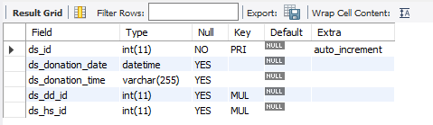

Donate upon request slot book table
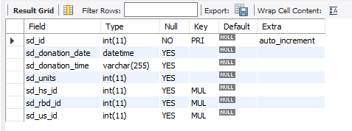
Feedback table
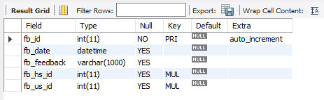
Faq table
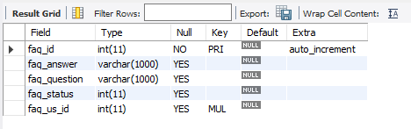

Appendices

Glossary
Acronyms | Definitions
null | null

Terms & Conditions
Interns shall be solely responsible for all its acts and omissions under this program. Interns will comply at all times with all applicable laws. Interns shall not use Cognizant’s name, logo and trademark in any promotional materials or other communications with third parties without the prior written consent of Cognizant. Any materials used by interns in relation to program will not infringe the copyrights, trademarks, patents, trade secrets or other intellectual property rights, privacy or similar rights of any person or entity. Interns agrees not to post, draw, make, display any content that is threatening, libelous, obscene, defamatory, abusive, pornographic, or advocates/encourages any conduct that could constitute a criminal offence or give rise to any civil liability. Cognizant its associates’ personal details including but not limited to name, address, contact number shall not be shared or forwarded to any third party, without prior written consent of Cognizant, its associates. All intellectual property provided by Cognizant, as part of program shall be owned exclusively by Cognizant. Intern shall indemnify, defend and indemnify Cognizant its associates, officers, directors from and against any claims, demands, loss, damage, liability, causes of action, judgments, or costs and expenses of every nature (including attorney’s fees and expenses) incurred by Cognizant based on any claim that any breach of terms and conditions of this program

Change Log
Please note that this table needs to be maintained even if a Configuration Management tool is used.
Version Number | Changes made
V<n.n> | <If the change details are not explicitly documented in the table below, reference should be provided here>
V<n.n> | Page no | Changed by | Effective date | Changes effected
V<n.n> | 1-11 | Vikrant Daptardar & Utkarsh Shrivastava | 10/12/2019 | First update
V<n.n> | 1-16 | Vikrant daptardar | 10/24/2019 | Final update

